**WIRING OF LED – LIGHT EMITTING DIODE**

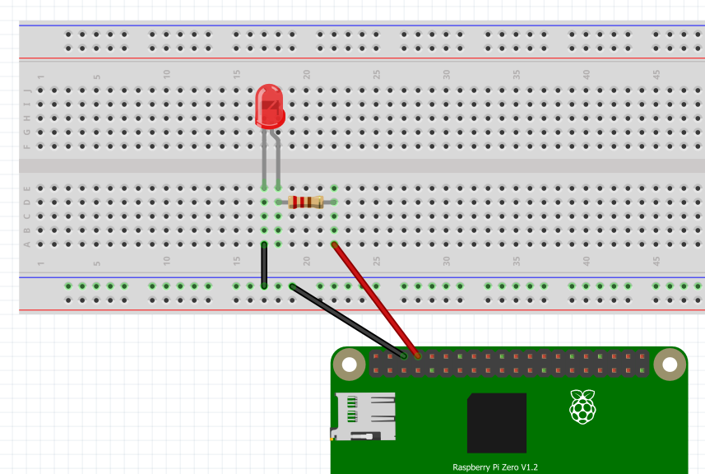

RASPBERRY PI

**200 OHM RESISTOR**

**-VE CATHODE**

**+ve ANODE**

**LED**

**USB PORTS**

**GROUND**

**PIN 14**

